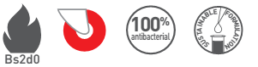
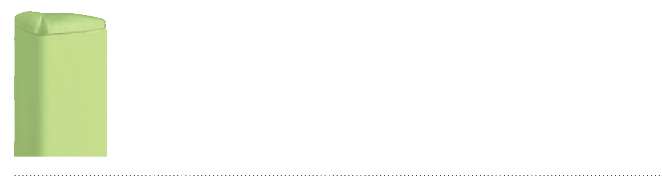
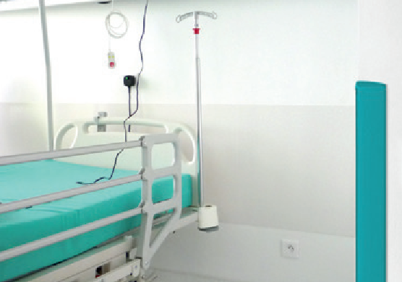

SPECIFICATION

LINEA’FLEX
FLEXIBLE ADHESIVE CORNER PROTECTOR
WITH VARIABLE ANGLE ENDCAP

- Description: variable angle adhesive corner protector (from 80° to 150°) with a variable angle endcap (Linea’Flex as manufactured by SPM) from smooth and antibacterial PVC, 1 mm to 3 mm, achieving Bs2d0 fire rating with solid colour. A protective film is specified to minimise cleaning before acceptance. Wings are 45 mm wide (internal measurement) and the central part is reinforced with two impact-absorbing dampers. The wrenching grip is minimal by the progressive thickness (1 to 3 mm) and the beveled shape of the wings. The corner protector is provided with 2 strips of foam adhesive tape for fixing and is finished with a smooth and beveled PVC endcap. This adhesive corner protector achieves an impact resistance in excess of 110 Joules, i.e., an impact of more than 320 kg travelling at 3 km/h.
- Environment: no heavy metals and no substance potentially subjected to any REACH restriction are used in its manufacture, nor PBT/BPA. The calcium-zinc thermal stabilisation process is used. The emission level of volatile substance in inside air has been tested according to ISO 16000-6 and is very low (A+) according to the French regulation (23 March 2011 nr 2011-321 Decree and 19 April 2011 Order). 100% of the product are recyclable.
- Colour: selected by architects from manufacturer’s standard range.
- Installation method: adhesive. SPM universal mastic glue is recommended for stronger fixing.
